Time Series Analysis (TSA) Summary

Table of Contents
Time Series Analysis (TSA) Summary 1
1. What is Time Series? 2
Importance of Time Series Analysis 2
3. Components of Time Series 2
Decomposition Formula: 2
4. White Noise 2
5. ARIMA Model 3
Definition: 3
What is Stationarity? 3
Why Stationarity is Important? 3
Step-by-Step Guide to ARIMA: 3
ARIMA Formula: 3
6. ACF and PACF 4
ACF (Auto-Correlation Function): 4
PACF (Partial Auto-Correlation Function): 4
Usage: 4
7. AR and MA Models 4
Auto-Regressive (AR) Model: 4
Moving Average (MA) Model: 4
8. ARIMA Example 5
Data: 5
Steps: 5
9. Python Code Example 5
10. Dickey-Fuller Test 6
Annexes 6
Auto-Correlation Function (ACF) and Partial Auto-Correlation Function (PACF) 6
1. Auto-Correlation Function (ACF) 6
ACF Formula: 6
2. Partial Auto-Correlation Function (PACF) 7
PACF Formula: 7
How to Use ACF and PACF to Identify Model Parameters 7
Plots for ACF and PACF 8
Example Interpretation: 8
Python Example 8
Key Insights for ACF and PACF 9
What is Stationarity? 9
Why Stationarity is Important? 9
Sliding Window and moving average 13
Intuition behind AR and MA 15

1. What is Time Series?
A time series is a sequence of data points collected or recorded at successive points in time. It is often used to analyze trends, make forecasts, or understand underlying patterns.
Examples: Daily stock prices, monthly rainfall, yearly sales figures, annual GDP growth.

Importance of Time Series Analysis
- Trend Analysis: Helps identify underlying trends in data.
- Forecasting: Predict future values based on past data.
- Seasonality Detection: Identifies repeating patterns over time.
- Anomaly Detection: Finds outliers or unusual behaviors.
- Decision Making: Aids in making informed business or scientific decisions.

3. Components of Time Series
- Trend (Tt): Long-term upward/downward movement in data.
- Seasonality (St): Repeating patterns over a fixed period.
- Cyclicality (Ct): Non-fixed, repeating patterns (e.g., economic cycles).
- Irregular/Noise (It): Random variations.

Decomposition Formula:
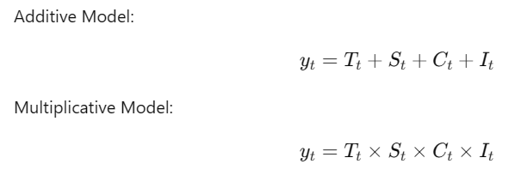

4. White Noise
A purely random series with:
- Constant mean (μ).
- Constant variance (σ2).
- No correlation between values.
Formula:
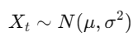

5. ARIMA Model

Definition:
ARIMA (p,d,q) combines:
- AR (Auto-Regressive): Current value depends on its own past values.
- I (Integrated): Differencing to make the series stationary.
- MA (Moving Average): Current value depends on past error terms.

What is Stationarity?
A time series is stationary if:
- Its mean is constant over time.
- Its variance is constant over time.
- It has no seasonality or trends.

Why Stationarity is Important?
Many statistical models (like ARIMA) assume stationarity because:
- It simplifies modeling and ensures stable predictions.

Step-by-Step Guide to ARIMA:
- Check Stationarity:
  - Use visual inspection or Dickey-Fuller Test.
  - Non-stationary data requires differencing.
- Differencing:
  - Apply first differencing (d=1):
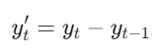
  - If necessary, apply higher-order differencing.
- Use ACF and PACF:
  - ACF identifies q (MA terms).
  - PACF identifies p (AR terms).
- Fit ARIMA:
  - Combine p,d,q parameters to model the series.

ARIMA Formula:

6. ACF and PACF

ACF (Auto-Correlation Function):
Measures correlation between current and lagged values.
Formula:
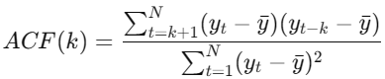

PACF (Partial Auto-Correlation Function):
Measures the direct correlation between yt and yt−k, removing the influence of intermediate lags.

Usage:
- Use ACF to determine q (MA terms).
- Use PACF to determine p (AR terms).

7. AR and MA Models

Auto-Regressive (AR) Model:
- Models the series using its own past values.
Example:
Predict temperature today using temperatures of the last 2 days (AR(2)):
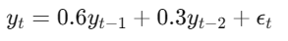

Moving Average (MA) Model:
- Models the series using past errors (residuals).
Example:
Predict sales using random shocks from the past 2 weeks (MA(2)):
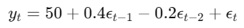

8. ARIMA Example

Data:
Monthly sales: [120,130,145,160,180].

Steps:
- Check Stationarity:
  - Series is non-stationary (has an upward trend).
- First Differencing:
  - yt′=[130−120,145−130,160−145,180−160]=[10,15,15,20].
- Use ACF and PACF:
  - ACF cuts off after lag 1 (q=1).
  - PACF cuts off after lag 2 (p=2).
- Fit ARIMA(2, 1, 1):
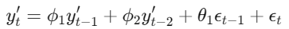

9. Python Code Example
import pandas as pd
import matplotlib.pyplot as plt
from statsmodels.tsa.arima.model import ARIMA
from statsmodels.graphics.tsaplots import plot_acf, plot_pacf

# Simulated data
data = [120, 130, 145, 160, 180]
time_series = pd.Series(data)

# Plot ACF and PACF
plot_acf(time_series.diff().dropna(), lags=4)
plt.title("ACF Plot")
plt.show()

plot_pacf(time_series.diff().dropna(), lags=4)
plt.title("PACF Plot")
plt.show()

# Fit ARIMA model
model = ARIMA(time_series, order=(2, 1, 1))
result = model.fit()

# Model summary
print(result.summary())

# Forecast
forecast = result.forecast(steps=3)
print("Forecast:", forecast)

10. Dickey-Fuller Test
Used to check for stationarity.
Test Equation:
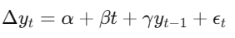
- Null hypothesis (H0): Series is non-stationary.
- If p-value < 0.05, reject H0 (series is stationary).

Annexes

Auto-Correlation Function (ACF) and Partial Auto-Correlation Function (PACF)
The ACF and PACF are key tools for identifying the parameters p (AR terms) and q (MA terms) in ARIMA models.

Auto-Correlation Function (ACF)
The ACF measures the correlation between a time series and its lagged values. It shows how strongly current values are related to past values.

ACF Formula:

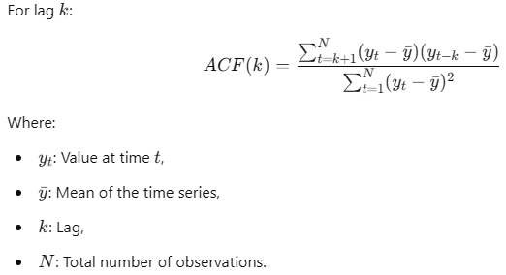

Partial Auto-Correlation Function (PACF)
The PACF measures the correlation between the time series and its lagged values, removing the effects of intermediate lags. It isolates the direct relationship between yt and yt−k.

PACF Formula:
The PACF for lag k is computed by regressing yt on all intermediate lags yt−1,yt−2,…,yt−k and extracting the coefficient for yt−k. In simple terms, it is the conditional correlation between yt and yt−k

How to Use ACF and PACF to Identify Model Parameters
- ACF:
  - Determines the order q (MA terms).
  - Examine the ACF plot and note where it cuts off (drops to near zero).
- PACF:
  - Determines the order p (AR terms).
  - Examine the PACF plot and note where it cuts off (drops to near zero).

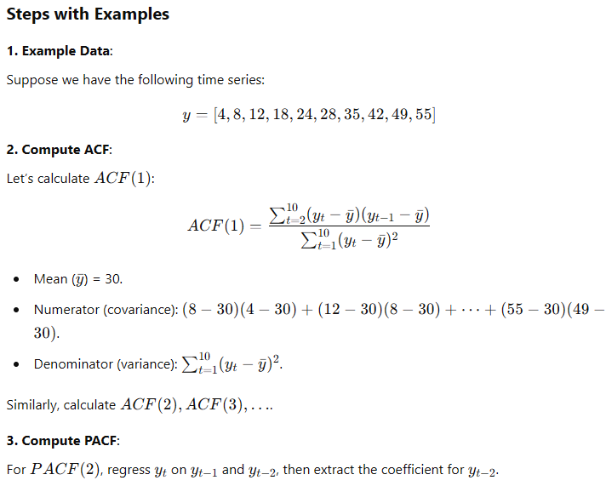

Plots for ACF and PACF
- ACF Plot:
  - Shows how the correlation decays with increasing lags.
  - Identify q where ACF cuts off.
- PACF Plot:
  - Shows direct correlations with each lag.
  - Identify p where PACF cuts off.

Example Interpretation:
- If the ACF cuts off after lag 2: q=2 (MA(2)).
- If the PACF cuts off after lag 3: p=3 (AR(3)).

Python Example
Here’s how you can plot ACF and PACF to determine p and q:

import pandas as pd
import matplotlib.pyplot as plt
from statsmodels.graphics.tsaplots import plot_acf, plot_pacf

# Example data
data = [4, 8, 12, 18, 24, 28, 35, 42, 49, 55]
time_series = pd.Series(data)

# Plot ACF
plot_acf(time_series, lags=5)
plt.title("ACF Plot")
plt.show()

# Plot PACF
plot_pacf(time_series, lags=5, method='ywm')
plt.title("PACF Plot")
plt.show()

Key Insights for ACF and PACF
- Use ACF to find qqq (number of MA terms).
  - Look for the lag where ACF cuts off.
- Use PACF to find ppp (number of AR terms).
  - Look for the lag where PACF cuts off.
- These plots guide you to choose the correct parameters for your ARIMA(p,d,q) model.

What is Stationarity?
A time series is stationary if:
- Its mean is constant over time.
- Its variance is constant over time.
- It has no seasonality or trends.

Why Stationarity is Important?
Many statistical models (like ARIMA) assume stationarity because:
- It simplifies modeling and ensures stable predictions.
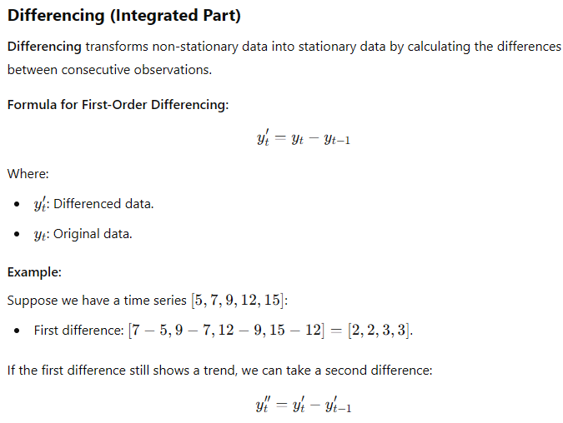
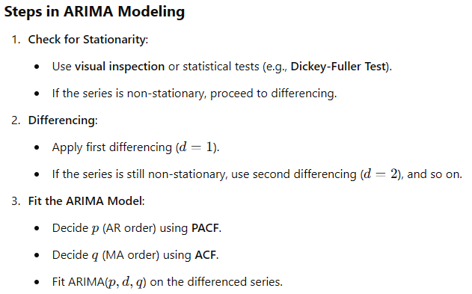

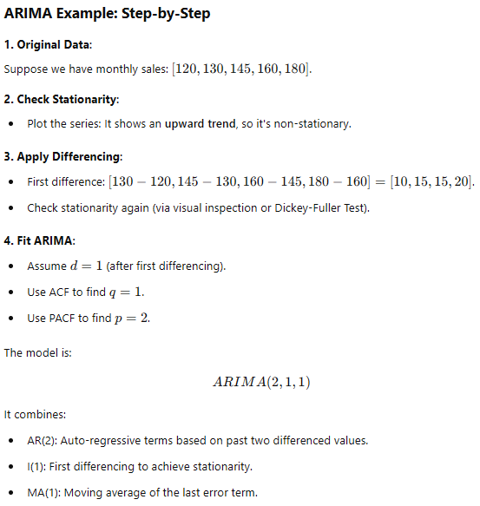
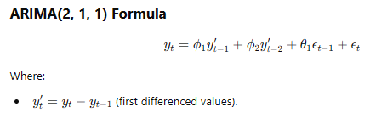

Sliding Window and moving average
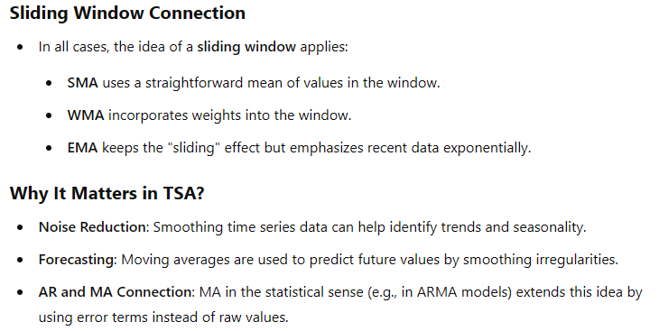

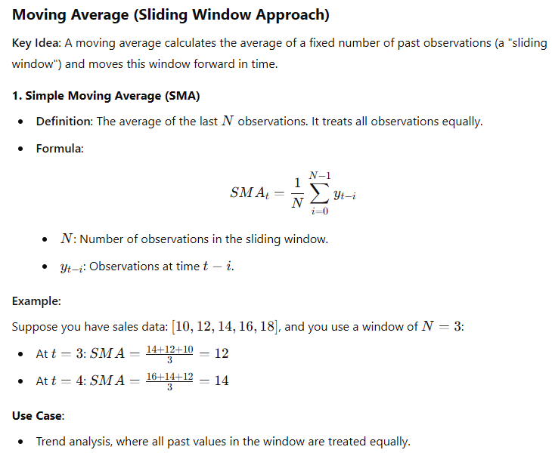

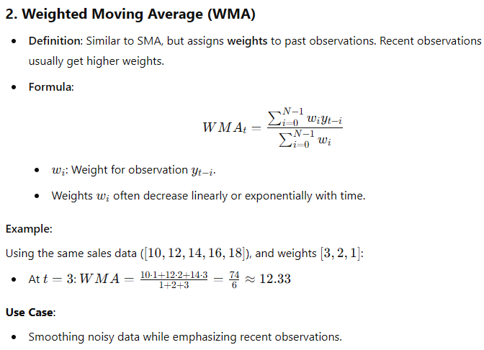

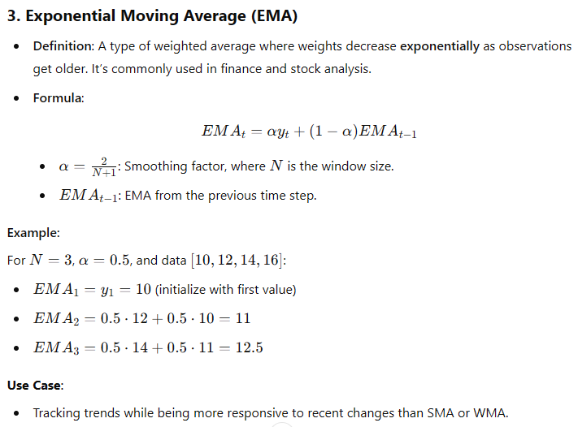

Intuition behind AR and MA

